# Food Desert Code

# Kaitlyn Keebaugh, Matthew Pergolski, Miranda Braman, Victor Yamaykin

IST707

# Section 1: Rule Mining

**LIBRARIES**

# library(knitr)

# library(magrittr)

# library(tidyverse)

# library(DataExplorer)

# library(ggplot2)

# library(arules)

# library(arulesViz)

# library(ROSE)

# library(randomForest)

# library(caret)

# library(e1071)

# library(dplyr)

# library(RColorBrewer)

# library(neuralnet)

# library(arm)

# library(rpart.plot)

# library(rpart)

# library(rattle)

# library(plotly)

# library(tidyverse)

# library(cluster)

# library(factoextra)

# library(dendextend)

# library(DescTools)

# LOAD PACKAGES & DATA SET

# Load Data Set  
 project_data <- read.csv("C:\\Users\\kkeeb\\Documents\\Balanced_FoodDesertComparisonData_2006_2019.csv",stringsAsFactors = TRUE)

introduce(project_data)

table(project_data$foodDesert)

*# Oversampling test*

set.seed(42)

barplot(prop.table(table(project_data$foodDesert)),

col = rainbow(2),

ylim = c(0,0.7),

main = "Class Distribution")

under_sampled <-ovun.sample(foodDesert~., data=project_data,seed=1, method="under")$data

table(under_sampled$foodDesert)

plot_correlation(project_data, maxcat=5L)

table(discretize(project_data$Pop2010, breaks=3))

hist(project_data$Pop2010, breaks = 12, main = "Equal Frequency Discretization")

##   
## [36,3.13e+03) [3.13e+03,4.73e+03) [4.73e+03,2.97e+04]   
## 333 333 334

ARM_ready_data <- discretizeDF(project_data, methods = list(

Pop2010 = list(method = "frequency", breaks = 5,

labels = c("very low", "low", "medium", "high", "very high")),

OHU2010 = list(method = "frequency", breaks = 3,

labels = c("low", "medium", "high")),

PovertyRate = list(method = "frequency", breaks = 3,

labels = c("low", "medium", "high")),

MedianFamilyIncome = list(method = "frequency", breaks = 3,

labels = c("low", "medium", "high"))),default = list(method = "none"))

*# Turn the data set to transactions*

tid <- as.character(ARM_ready_data$CensusTract)

ARM_ready_data$id <- NULL

transactions <- as(ARM_ready_data, "transactions")

transactionInfo(transactions)[["transactionID"]] <- tid

str(project_data)

plot_str(project_data)

introduce(project_data)

plot_correlation(project_data, maxcat=5L)

plot_prcomp(na.omit(project_data), variance_cap = 0.8, nrow = 2L, ncol = 2L)

plot(project_data$PovertyRate, project_data$MedianFamilyIncome)

plot_scatterplot(project_data[, c("PovertyRate", "MedianFamilyIncome")], by="PovertyRate", sampled_rows = 1000L)

p <- ggplot(project_data[sample(nrow(project_data), 250), ], aes(MedianFamilyIncome, PovertyRate, color=foodDesert, size = Pop2010*10,

main="Food")) + geom_point(na.rm = T)

## CensusTract State County Urban Pop2010 OHU2010  
## 1 17031381800 Illinois Cook County 1 very low low  
## 2 42003483800 Pennsylvania Allegheny County 1 low medium  
## 3 13117130612 Georgia Forsyth County 1 very high medium  
## 4 45091060905 South Carolina York County 1 very high high  
## 5 6037501504 California Los Angeles County 1 medium medium  
## 6 48141010336 Texas El Paso County 1 very high high  
## LowIncomeTracts PovertyRate MedianFamilyIncome foodDesert  
## 1 1 medium medium 1  
## 2 1 high low 1  
## 3 0 low high 1  
## 4 0 medium medium 1  
## 5 1 high low 1  
## 6 0 medium medium 1

## 'data.frame': 1000 obs. of 10 variables:  
## $ CensusTract : num 1.70e+10 4.20e+10 1.31e+10 4.51e+10 6.04e+09 ...  
## $ State : chr "Illinois" "Pennsylvania" "Georgia" "South Carolina" ...  
## $ County : chr "Cook County" "Allegheny County" "Forsyth County" "York County" ...  
## $ Urban : int 1 1 1 1 1 1 0 1 1 1 ...  
## $ Pop2010 : int 1188 3165 5614 8916 3592 6638 2128 1193 2632 2300 ...  
## $ OHU2010 : int 591 1485 1740 3663 1588 1986 822 606 815 1066 ...  
## $ LowIncomeTracts : int 1 1 0 0 1 0 0 1 1 1 ...  
## $ PovertyRate : num 23.4 35.2 1.8 17.3 24.3 13.7 10.7 41.9 33 20.4 ...  
## $ MedianFamilyIncome: int 60938 26336 151944 60625 45208 56510 85703 25441 39958 56797 ...  
## $ foodDesert : int 1 1 1 1 1 1 1 1 1 1 ...

## rows columns discrete_columns continuous_columns all_missing_columns  
## 1 1000 10 2 8 0  
## total_missing_values complete_rows total_observations memory_usage  
## 1 0 1000 10000 93816

*# Look at relative frequency plot to see how many times these items have #appeared as compared to others*

itemFrequencyPlot(transactions, topN=20, type="relative", col=brewer.pal(8, 'Pastel2'),main="Relative Item Frequency Plot for Food Access Research Atlas (FARA)")

**APRIORI**

*## Apriori*  
*# Get the rules with low support and low confidence*

rules <- apriori(transactions, parameter = list(supp = 0.02, conf = 0.7, minlen=4))

*# Show rules*

inspect(rules[1:20])

*## Sort by lift*

SortedRules_conf <- sort(rules, by="confidence", decreasing=F)

inspect(SortedRules_conf[1:50])

*## Take the top 10 rules sorted by lift*

top10rules_conf <- head(SortedRules_conf, n = 10, by = "confidence")

inspect(top10rules_conf)

## Parameter specification:  
## confidence minval smax arem aval originalSupport maxtime support minlen  
## 0.7 0.1 1 none FALSE TRUE 5 0.02 4  
## maxlen target ext  
## 10 rules TRUE  
##   
## Algorithmic control:  
## filter tree heap memopt load sort verbose  
## 0.1 TRUE TRUE FALSE TRUE 2 TRUE  
##   
## Absolute minimum support count: 20   
##   
## set item appearances ...[0 item(s)] done [0.00s].  
## set transactions ...[70 item(s), 1000 transaction(s)] done [0.00s].  
## sorting and recoding items ... [41 item(s)] done [0.00s].  
## creating transaction tree ... done [0.00s].  
## checking subsets of size 1 2 3 4 5 6 7 8 done [0.00s].  
## writing ... [7915 rule(s)] done [0.00s].  
## creating S4 object ... done [0.00s].

## lhs rhs support confidence coverage lift count  
## [1] {CensusTract=[3.72e+10,5.51e+10],   
## State=Tennessee,   
## Urban=[0,1]} => {LowIncomeTracts=[0,1]} 0.02 1 0.02 1 20  
## [2] {CensusTract=[3.72e+10,5.51e+10],   
## State=Tennessee,   
## LowIncomeTracts=[0,1]} => {Urban=[0,1]} 0.02 1 0.02 1 20  
## [3] {State=Tennessee,   
## Urban=[0,1],   
## LowIncomeTracts=[0,1]} => {CensusTract=[3.72e+10,5.51e+10]} 0.02 1 0.02 3 20  
## [4] {CensusTract=[3.72e+10,5.51e+10],   
## State=Tennessee,   
## Urban=[0,1]} => {foodDesert=[1,2]} 0.02 1 0.02 1 20  
## [5] {CensusTract=[3.72e+10,5.51e+10],   
## State=Tennessee,   
## foodDesert=[1,2]} => {Urban=[0,1]} 0.02 1 0.02 1 20  
## [6] {State=Tennessee,   
## Urban=[0,1],   
## foodDesert=[1,2]} => {CensusTract=[3.72e+10,5.51e+10]} 0.02 1 0.02 3 20  
## [7] {CensusTract=[3.72e+10,5.51e+10],   
## State=Tennessee,   
## LowIncomeTracts=[0,1]} => {foodDesert=[1,2]} 0.02 1 0.02 1 20  
## [8] {CensusTract=[3.72e+10,5.51e+10],   
## State=Tennessee,   
## foodDesert=[1,2]} => {LowIncomeTracts=[0,1]} 0.02 1 0.02 1 20  
## [9] {State=Tennessee,   
## LowIncomeTracts=[0,1],   
## foodDesert=[1,2]} => {CensusTract=[3.72e+10,5.51e+10]} 0.02 1 0.02 3 20  
## [10] {State=Tennessee,   
## Urban=[0,1],   
## LowIncomeTracts=[0,1]} => {foodDesert=[1,2]}

## lhs rhs support confidence coverage lift count  
## [1] {CensusTract=[1.81e+10,3.72e+10),   
## Urban=[0,1],   
## PovertyRate=medium} => {MedianFamilyIncome=medium} 0.070 0.70 0.100 2.1 70  
## [2] {CensusTract=[1.81e+10,3.72e+10),   
## LowIncomeTracts=[0,1],   
## PovertyRate=medium} => {MedianFamilyIncome=medium} 0.070 0.70 0.100 2.1 70  
## [3] {CensusTract=[1.81e+10,3.72e+10),   
## PovertyRate=medium,   
## foodDesert=[1,2]} => {MedianFamilyIncome=medium} 0.070 0.70 0.100 2.1 70  
## [4] {CensusTract=[1.81e+10,3.72e+10),   
## Urban=[0,1],   
## LowIncomeTracts=[0,1],   
## PovertyRate=medium} => {MedianFamilyIncome=medium} 0.070 0.70 0.100 2.1 70

## lhs rhs support confidence coverage lift count  
## [1] {CensusTract=[3.72e+10,5.51e+10],   
## State=Tennessee,   
## Urban=[0,1]} => {LowIncomeTracts=[0,1]} 0.02 1 0.02 1 20  
## [2] {CensusTract=[3.72e+10,5.51e+10],   
## State=Tennessee,   
## LowIncomeTracts=[0,1]} => {Urban=[0,1]} 0.02 1 0.02 1 20  
## [3] {State=Tennessee,   
## Urban=[0,1],   
## LowIncomeTracts=[0,1]} =>

*## Visualize the rules with a parallel coordinate plot*

plot(top10rules_conf, method = "paracoord")

plot(top10rules_conf, method = "graph", interactive = T)

**Section 2: Clustering**

# PRE-PROCESSING / DATA MUNGING

project_data -> raw.data.cluster

str(raw.data.cluster)

## 'data.frame': 1000 obs. of 10 variables:  
## $ CensusTract : num 1.70e+10 4.20e+10 1.31e+10 4.51e+10 6.04e+09 ...  
## $ State : chr "Illinois" "Pennsylvania" "Georgia" "South Carolina" ...  
## $ County : chr "Cook County" "Allegheny County" "Forsyth County" "York County" ...  
## $ Urban : int 1 1 1 1 1 1 0 1 1 1 ...  
## $ Pop2010 : int 1188 3165 5614 8916 3592 6638 2128 1193 2632 2300 ...  
## $ OHU2010 : int 591 1485 1740 3663 1588 1986 822 606 815 1066 ...  
## $ LowIncomeTracts : int 1 1 0 0 1 0 0 1 1 1 ...  
## $ PovertyRate : num 23.4 35.2 1.8 17.3 24.3 13.7 10.7 41.9 33 20.4 ...  
## $ MedianFamilyIncome: int 60938 26336 151944 60625 45208 56510 85703 25441 39958 56797 ...  
## $ foodDesert : int 1 1 1 1 1 1 1 1 1 1 ...

## rows columns discrete_columns continuous_columns all_missing_columns  
## 1 1000 10 2 8 0  
## total_missing_values complete_rows total_observations memory_usage  
## 1 0 1000 10000 93816

##   
## 1 2   
## 500 500

# Convert Data to Numeric-Only For Clustering  
 colnames(data.cluster[,c(1,2,3,4)])

## [1] "Group.1" "CensusTract" "State" "County"

str(data.cluster[,c(-1,-2,-3,-4)])

## 'data.frame': 50 obs. of 7 variables:  
## $ Urban : num 0.667 0 0.833 0.556 0.901 ...  
## $ Pop2010 : num 4060 4193 4378 3422 4608 ...  
## $ OHU2010 : num 1604 1688 1573 1375 1563 ...  
## $ LowIncomeTracts : num 0.524 0 0.583 0.778 0.582 ...  
## $ PovertyRate : num 24.7 9.8 20.9 22.1 15.9 ...  
## $ MedianFamilyIncome: num 50854 92000 56345 50307 79064 ...  
## $ foodDesert : num 1.48 1 1.46 1.78 1.32 ...

num.data.cluster <- data.cluster[,c(-1,-2,-3,-4)]  
 num.data.cluster <- as.data.frame(scale(num.data.cluster))  
 str(num.data.cluster)

## 'data.frame': 50 obs. of 7 variables:  
## $ Urban : num -0.128 -2.877 0.559 -0.586 0.838 ...  
## $ Pop2010 : num 0.214 0.408 0.678 -0.719 1.014 ...  
## $ OHU2010 : num 0.422 0.768 0.293 -0.531 0.249 ...  
## $ LowIncomeTracts : num -0.3397 -2.5871 -0.0843 0.75 -0.0882 ...  
## $ PovertyRate : num 0.898 -1.585 0.268 0.478 -0.557 ...  
## $ MedianFamilyIncome: num -0.728 1.793 -0.391 -0.761 1 ...  
## $ foodDesert : num -0.133 -2.289 -0.214 1.232 -0.846 ...

# MODELS

*# Optimal Amount of Clusters | Average Silhouette Method*

fviz_nbclust(num.data.cluster, FUN = hcut, method = "silhouette")

*# plot shows 3 optimal clusters*

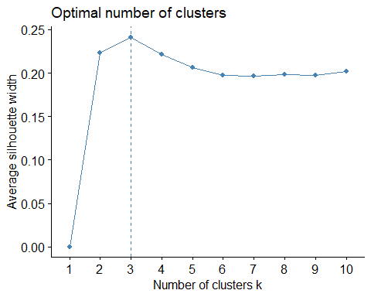

# Agnes Function | Dendrogram

# Determine Optimal Agnes Method  
 m.assess <- c("average", "single", "complete", "ward")  
 names(m.assess) <- c( "average", "single", "complete", "ward")  
   
 compute.coeff <- function(x)   
 {  
 agnes(num.data.cluster, method = x)$ac  
 }  
   
 hc.coeff.df <- as.data.frame(map_dbl(m.assess, compute.coeff))  
 hc.coeff.df

## map_dbl(m.assess, compute.coeff)  
## average 0.7337589  
## single 0.5997242  
## complete 0.8469888  
## ward 0.8895291

# Method 'ward' conveys highest quality with 0.8895291  
   
 H.C <- agnes(num.data.cluster, method = "ward")  
   
 # Agglomerative coefficient (which measures the amount of clustering structure found)  
 # (values closer to 1 suggest strong clustering structure)  
 H.C$ac

## [1] 0.8895291

## [1] 0.8895291  
   
 pltree(H.C, cex = 0.6, hang = -1, main = "Dendrogram of AGNES")   
 rect.hclust(H.C, k = 3, border = 2:5)

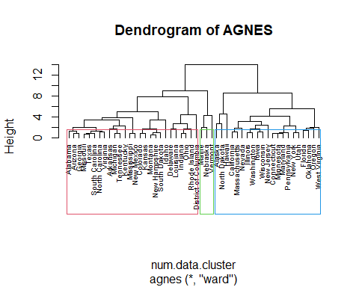

# hclust Function / Dendrogram

# Dissimilarity matrix  
 d <- dist(num.data.cluster, method = "euclidean")  
 #d  
 # Hierarchical clustering using Complete Linkage  
 hc1 <- hclust(d, method = "ward.D" )  
   
 # Plot the obtained dendrogram  
 plot(hc1, cex = 0.6, hang = -1)  
 rect.hclust(hc1, k = 3, border = 2:5)

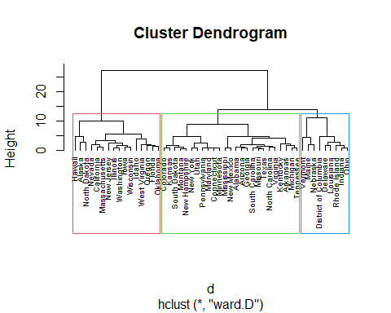

#fviz_nbclust(num.data.cluster, kmeans, method = "wss")

# K MEANS

k.means <- kmeans(num.data.cluster, 3)  
 k.means

## K-means clustering with 3 clusters of sizes 4, 15, 31  
##   
## Cluster means:  
## Urban Pop2010 OHU2010 LowIncomeTracts PovertyRate  
## 1 -0.9086002 0.8152088 0.7177478 -2.26061986 -1.7716848  
## 2 -0.2280598 -0.9927497 -1.0534376 0.78546056 0.9185914  
## 3 0.2275903 0.3751745 0.4171152 -0.08836867 -0.2158752  
## MedianFamilyIncome foodDesert  
## 1 2.2236455 -1.2306823  
## 2 -0.8477377 0.4461845  
## 3 0.1232736 -0.0570980  
##   
## Clustering vector:  
## Alabama Alaska Arizona   
## 3 1 3   
## Arkansas California Colorado   
## 2 3 3   
## Connecticut Delaware District of Columbia   
## 3 2 2   
## Florida Georgia Hawaii   
## 3 3 1   
## Idaho Illinois Indiana   
## 3 3 2   
## Iowa Kansas Kentucky   
## 3 3 2   
## Louisiana Maine Maryland   
## 2 2 3   
## Massachusetts Michigan Minnesota   
## 3 3 3   
## Mississippi Missouri Montana   
## 2 3 3   
## Nebraska Nevada New Hampshire   
## 2 3 3   
## New Jersey New Mexico New York   
## 1 2 3   
## North Carolina North Dakota Ohio   
## 2 1 2   
## Oklahoma Oregon Pennsylvania   
## 3 3 3   
## Rhode Island South Carolina South Dakota   
## 2 3 3   
## Tennessee Texas Utah   
## 2 3 3   
## Vermont Virginia Washington   
## 2 3 3   
## West Virginia Wisconsin   
## 3 3   
##   
## Within cluster sum of squares by cluster:  
## [1] 20.25762 90.21556 84.16343  
## (between_SS / total_SS = 43.3 %)  
##   
## Available components:  
##   
## [1] "cluster" "centers" "totss" "withinss" "tot.withinss"  
## [6] "betweenss" "size" "iter" "ifault"

k.means$centers

## Urban Pop2010 OHU2010 LowIncomeTracts PovertyRate  
## 1 -0.9086002 0.8152088 0.7177478 -2.26061986 -1.7716848  
## 2 -0.2280598 -0.9927497 -1.0534376 0.78546056 0.9185914  
## 3 0.2275903 0.3751745 0.4171152 -0.08836867 -0.2158752  
## MedianFamilyIncome foodDesert  
## 1 2.2236455 -1.2306823  
## 2 -0.8477377 0.4461845  
## 3 0.1232736 -0.0570980

assignment_clusters <- data.frame(num.data.cluster, k.means$cluster)  
 assignment_clusters

head(assignment_clusters)

## Urban Pop2010 OHU2010 LowIncomeTracts PovertyRate  
## Alabama -0.1280735 0.2137247 0.4222219 -0.33966663 0.8983645  
## Alaska -2.8767226 0.4084355 0.7684432 -2.58707088 -1.5848068  
## Arizona 0.5590888 0.6782671 0.2926119 -0.08427978 0.2676231  
## Arkansas -0.5861817 -0.7186934 -0.5309601 0.74998392 0.4784008  
## California 0.8384845 1.0141702 0.2494695 -0.08820881 -0.5570090  
## Colorado 0.5952552 -0.0234643 0.1716279 -0.10309776 -0.5221703  
## MedianFamilyIncome foodDesert k.means.cluster  
## Alabama -0.7276807 -0.1329249 3  
## Alaska 1.7928665 -2.2886065 1  
## Arizona -0.3912764 -0.2137629 3  
## Arkansas -0.7611959 1.2323401 2  
## California 1.0004205 -0.8459580 3  
## Colorado 0.3378109 1.0470272 3

clusplot(num.data.cluster, k.means$cluster, color=T, shade=T,  
 Labels=2, lines=0) # plot clusters

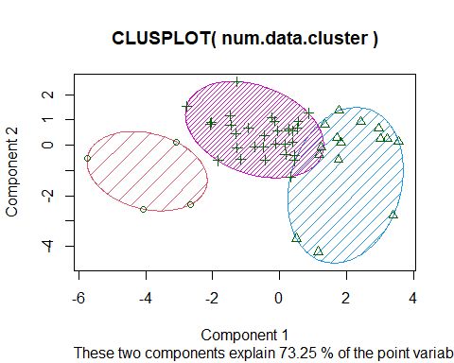

fviz_cluster(k.means, data = num.data.cluster,   
 main = 'Cluster Plot',  
 xlab = '',  
 ylab = '', pointsize = num.data.cluster$PovertyRate)

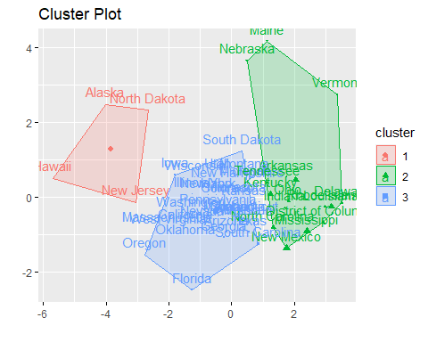

# Helpful Data Tables  
 # Create Separate DF  
 main.cluster.df <- data.frame(raw.data.cluster, k.means$cluster)

## Warning in data.frame(raw.data.cluster, k.means$cluster): row names were found  
## from a short variable and have been discarded

main.cluster.df <- main.cluster.df[,c(-1,-3,-4)]  
 head(main.cluster.df)

## State Pop2010 OHU2010 LowIncomeTracts PovertyRate MedianFamilyIncome  
## 1 Illinois 1188 591 1 23.4 60938  
## 2 Pennsylvania 3165 1485 1 35.2 26336  
## 3 Georgia 5614 1740 0 1.8 151944  
## 4 South Carolina 8916 3663 0 17.3 60625  
## 5 California 3592 1588 1 24.3 45208  
## 6 Texas 6638 1986 0 13.7 56510  
## foodDesert k.means.cluster  
## 1 1 3  
## 2 1 1  
## 3 1 3  
## 4 1 2  
## 5 1 3  
## 6 1 3

# Discretize Poverty Rate  
 pv.bins <- 3  
   
 min.pv <- min(main.cluster.df$PovertyRate)  
 min.pv

## [1] 0

max.pv <- max(main.cluster.df$PovertyRate)  
 max.pv

## [1] 82.8

mid.pv <- (max.pv - min.pv) / pv.bins  
 mid.pv

## [1] 27.6

mid.pv * 3

## [1] 82.8

main.cluster.df$DiscPovertyRate <- cut(main.cluster.df$PovertyRate,  
 breaks = c(min.pv, mid.pv, max.pv, Inf),  
 labels = c('Min', 'Mid', 'Max'))  
   
 str(main.cluster.df)

## 'data.frame': 1000 obs. of 9 variables:  
## $ State : Factor w/ 50 levels "Alabama","Alaska",..: 14 39 11 41 5 44 28 39 11 10 ...  
## $ Pop2010 : int 1188 3165 5614 8916 3592 6638 2128 1193 2632 2300 ...  
## $ OHU2010 : int 591 1485 1740 3663 1588 1986 822 606 815 1066 ...  
## $ LowIncomeTracts : int 1 1 0 0 1 0 0 1 1 1 ...  
## $ PovertyRate : num 23.4 35.2 1.8 17.3 24.3 13.7 10.7 41.9 33 20.4 ...  
## $ MedianFamilyIncome: int 60938 26336 151944 60625 45208 56510 85703 25441 39958 56797 ...  
## $ foodDesert : int 1 1 1 1 1 1 1 1 1 1 ...  
## $ k.means.cluster : int 3 1 3 2 3 3 3 2 2 3 ...  
## $ DiscPovertyRate : Factor w/ 3 levels "Min","Mid","Max": 1 2 1 1 1 1 1 2 2 1 ...

head(main.cluster.df)

## State Pop2010 OHU2010 LowIncomeTracts PovertyRate MedianFamilyIncome  
## 1 Illinois 1188 591 1 23.4 60938  
## 2 Pennsylvania 3165 1485 1 35.2 26336  
## 3 Georgia 5614 1740 0 1.8 151944  
## 4 South Carolina 8916 3663 0 17.3 60625  
## 5 California 3592 1588 1 24.3 45208  
## 6 Texas 6638 1986 0 13.7 56510  
## foodDesert k.means.cluster DiscPovertyRate  
## 1 1 3 Min  
## 2 1 1 Mid  
## 3 1 3 Min  
## 4 1 2 Min  
## 5 1 3 Min  
## 6 1 3 Min

cluster.1.df <- main.cluster.df[main.cluster.df$k.means.cluster == 1,]  
 Mode(cluster.1.df$DiscPovertyRate)

## [1] Min  
## attr(,"freq")  
## [1] 59  
## Levels: Min Mid Max

cluster.1.df

cluster.2.df <- main.cluster.df[main.cluster.df$k.means.cluster == 2,]  
 Mode(cluster.2.df$DiscPovertyRate)

## [1] Min  
## attr(,"freq")  
## [1] 216  
## Levels: Min Mid Max

mean(cluster.2.df$PovertyRate)

## [1] 20.80967

cluster.2.df

cluster.3.df <- main.cluster.df[main.cluster.df$k.means.cluster == 3,]  
 cluster.3.df <- na.omit(cluster.3.df)  
 Mode(cluster.3.df$DiscPovertyRate)

## [1] Min  
## attr(,"freq")  
## [1] 472  
## Levels: Min Mid Max

cluster.3.df

main.cluster.df <- aggregate(main.cluster.df, by = list(main.cluster.df$State), FUN = mean)

main.cluster.df

**Section 3: Classification Models**

**DECISION TREE PREP**

*## Must normalize some columns and make their numbers between 0 and 1 for ##Classification Models*

set.seed(341)  
  
#randomize the dataset  
fooddesert[sample(nrow(fooddesert)),]-> fooddesert

#make train 80% of data and test 20%  
nrow(fooddesert)*.8-> index  
fooddesert[1:index,]->train  
fooddesert[(index+1): nrow(fooddesert),]->test  
  
# check percentages   
prop.table(table(train$foodDesert))

##   
## 0 1   
## 0.5075 0.4925

prop.table(table(test$foodDesert))

##   
## 0 1   
## 0.47 0.53

**DECISION TREE MODELS**

*#decision tree 1*

train_tree1 <- rpart(foodDesert ~ ., data = train,

method="class", control=rpart.control(cp=0, maxdepth=7))

predicted1= predict(train_tree1, test, type="class")

fancyRpartPlot(train_tree1)

table(FoodDesert=predicted1, true=data_test$foodDesert)

*## Decision tree #2*

train_tree1 <- rpart(foodDesert ~ Urban+OHU2010+LowIncomeTracts+PovertyRate+MedianFamilyIncome,

data = train, method="class",

control=rpart.control(cp=0.013, maxdepth=4))

*#verify CP and size of tree*

rsq.rpart(train_tree1)

plotcp(train_tree1)

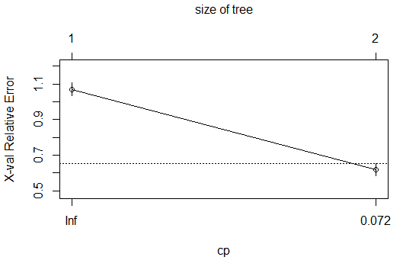

printcp(train_tree1)

## Classification tree:

## rpart(formula = foodDesert ~ Urban + OHU2010 + LowIncomeTracts +

## PovertyRate + MedianFamilyIncome, data = train, method = "class",

## control = rpart.control(cp = 0.013, maxdepth = 4))

##

## Variables actually used in tree construction:

## [1] MedianFamilyIncome

##

## Root node error: 397/800 = 0.49625

##

## n= 800

##

## CP nsplit rel error xerror xstd

## 1 0.40302 0 1.00000 1.07053 0.035553

## 2 0.01300 1 0.59698 0.61965 0.032877

predicted1= predict(train_tree1, test, type="class")

fancyRpartPlot(train_tree1)

confusionMatrix(predicted1, as.factor(test$foodDesert))

## Confusion Matrix and Statistics

##

## Reference

## Prediction 1 2

## 1 63 11

## 2 40 86

##

## Accuracy : 0.745

## 95% CI : (0.6787, 0.8039)

## No Information Rate : 0.515

## P-Value [Acc > NIR] : 2.232e-11

##

## Kappa : 0.4939

##

## Mcnemar's Test P-Value : 8.826e-05

##

## Sensitivity : 0.6117

## Specificity : 0.8866

## Pos Pred Value : 0.8514

## Neg Pred Value : 0.6825

## Prevalence : 0.5150

## Detection Rate : 0.3150

## Detection Prevalence : 0.3700

## Balanced Accuracy : 0.7491

##

## 'Positive' Class : 1

*## Decision Tree #3*

train_tree1 <- rpart(foodDesert ~ LowIncomeTracts+MedianFamilyIncome,

data = train, method="class",

control=rpart.control(cp=0.005, maxdepth=3))

rsq.rpart(train_tree1)

plotcp(train_tree1)

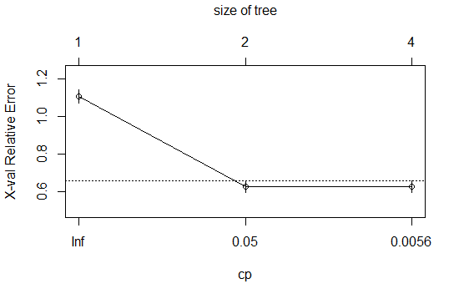

printcp(train_tree1)

## Classification tree:

## rpart(formula = foodDesert ~ LowIncomeTracts + MedianFamilyIncome,

## data = train, method = "class", control = rpart.control(cp = 0.005,

## maxdepth = 3))

##

## Variables actually used in tree construction:

## [1] LowIncomeTracts MedianFamilyIncome

##

## Root node error: 397/800 = 0.49625

##

## n= 800

##

## CP nsplit rel error xerror xstd

## 1 0.4030227 0 1.00000 1.1058 0.035453

## 2 0.0062972 1 0.59698 0.6272 0.032987

## 3 0.0050000 3 0.58438 0.6272 0.032987

predicted1= predict(train_tree1, test, type="class")

fancyRpartPlot(train_tree1)

confusionMatrix(predicted1, as.factor(test$foodDesert))

## Confusion Matrix and Statistics

##

## Reference

## Prediction 1 2

## 1 61 5

## 2 42 92

##

## Accuracy : 0.765

## 95% CI : (0.7, 0.8219)

## No Information Rate : 0.515

## P-Value [Acc > NIR] : 3.060e-13

##

## Kappa : 0.5347

##

## Mcnemar's Test P-Value : 1.512e-07

##

## Sensitivity : 0.5922

## Specificity : 0.9485

## Pos Pred Value : 0.9242

## Neg Pred Value : 0.6866

## Prevalence : 0.5150

## Detection Rate : 0.3050

## Detection Prevalence : 0.3300

## Balanced Accuracy : 0.7703

##

## 'Positive' Class : 1

printcp(train_tree1)

**NEURAL NETWORKS**

#sed.seed to get the same results each time  
set.seed(24)  
  
#create a matrix with the columns you want to include in NN  
model.matrix(~OHU2010+LowIncomeTracts+PovertyRate+MedianFamilyIncome+foodDesert,  
 data=train)->train_matrix  
model.matrix(~OHU2010+LowIncomeTracts+PovertyRate+MedianFamilyIncome+foodDesert,  
 data=test)->test_matrix  
  
#create formulas in order to run it through the neural network  
#the first is with training data.   
#we take out the first and last column otherwise we get an integer column   
#and another fooddesert column  
col_list <- paste(c(colnames(train_matrix[,-c(1,6)])),collapse="+")  
col_list <- paste(c("foodDesert~",col_list),collapse="")  
f <- formula(col_list)

#create a formula for the test matrix  
col_list <- paste(c(colnames(test_matrix[,-c(1,6)])),collapse="+")  
col_list <- paste(c("foodDesert~",col_list),collapse="")  
m <- formula(col_list)  
  
#design and run the neural network  
neuralnet(f,data=train_matrix,hidden=1,  
 threshold = 0.01,  
 learningrate.limit = NULL,  
 learningrate.factor =  
 list(minus = 0.5, plus = 1.2),  
 algorithm = "rprop+") ->nn1  
plot(nn1)

#plug in the test matrix to the NN and name it  
output <- compute(nn1, test_matrix[,-c(1,6)],rep=1)  
summary(output)

## Length Class Mode   
## neurons 2 -none- list   
## net.result 200 -none- numeric

#create a subset of just the outcomes that we need, which is  
#the food desert predictions  
output$net.result->pred

#The outcome is many numbers between 0 and 1, so we tell the data to  
#change any number above .5 into a 1, and any number below a .5, into a 0  
ifelse(output$net.result>.5, 1, 0)->pred  
  
confusionMatrix(as.factor(pred), as.factor(test$foodDesert))

## Confusion Matrix and Statistics  
##   
## Reference  
## Prediction 0 1  
## 0 80 35  
## 1 14 71  
##   
## Accuracy : 0.755   
## 95% CI : (0.6894, 0.8129)  
## No Information Rate : 0.53   
## P-Value [Acc > NIR] : 4.656e-11   
##   
## Kappa : 0.5144   
##   
## Mcnemar's Test P-Value : 0.004275   
##   
## Sensitivity : 0.8511   
## Specificity : 0.6698   
## Pos Pred Value : 0.6957   
## Neg Pred Value : 0.8353   
## Prevalence : 0.4700   
## Detection Rate : 0.4000   
## Detection Prevalence : 0.5750   
## Balanced Accuracy : 0.7604   
##   
## 'Positive' Class : 0   
##

*## Must make sure that the data we are testing is the same variable type pred #is a number and test$fooddesert is a factor, so we need to include the #as.factor function for pred in order for confusion matrix to run correctly #can change the hidden layers, increase the number of neurons, add more data, #or change the learning algorithm parameters, to try and increase accuracy*

**KNN**

set.seed(341)  
  
*## create a smaller dataset*   
myvars<-c("Urban","OHU2010", "LowIncomeTracts", "PovertyRate", "MedianFamilyIncome", "foodDesert")  
train2<- train[myvars]  
test2<- test[myvars]  
as.factor(train2$foodDesert)->train2$foodDesert  
as.factor(test2$foodDesert)->test2$foodDesert  
  
#Used many numbers in tuneLength to help improve accuracy- 5,15,25,27,28,29  
train(foodDesert~., data=train2, method="knn", tuneLength=28)->yes  
predict(yes, test2)->guess  
#made both the variables factors  
confusionMatrix(guess, test2$foodDesert)

## Confusion Matrix and Statistics  
##   
## Reference  
## Prediction 0 1  
## 0 83 38  
## 1 11 68  
##   
## Accuracy : 0.755   
## 95% CI : (0.6894, 0.8129)  
## No Information Rate : 0.53   
## P-Value [Acc > NIR] : 4.656e-11   
##   
## Kappa : 0.5161   
##   
## Mcnemar's Test P-Value : 0.0002038   
##   
## Sensitivity : 0.8830   
## Specificity : 0.6415   
## Pos Pred Value : 0.6860   
## Neg Pred Value : 0.8608   
## Prevalence : 0.4700   
## Detection Rate : 0.4150   
## Detection Prevalence : 0.6050   
## Balanced Accuracy : 0.7622   
##   
## 'Positive' Class : 0   
##

**RANDOM FOREST**

set.seed(341)  
library(randomForest)

*## foodDesert must be a factor for random forest to run as a classification*

as.factor(train2$foodDesert)->train2$foodDesert  
as.factor(test2$foodDesert)->test2$foodDesert  
rfm <- randomForest(foodDesert~., data=train2, ntree=300, importance=T)  
rfm

##   
## Call:  
## randomForest(formula = foodDesert ~ ., data = train2, ntree = 300, importance = T)   
## Type of random forest: classification  
## Number of trees: 300  
## No. of variables tried at each split: 2  
##   
## OOB estimate of error rate: 27.38%  
## Confusion matrix:  
## 0 1 class.error  
## 0 333 73 0.1798030  
## 1 146 248 0.3705584

predRF <- predict(rfm, test2, type=c("class"))  
confusionMatrix(predRF, test2$foodDesert)

## Confusion Matrix and Statistics  
##   
## Reference  
## Prediction 0 1  
## 0 79 36  
## 1 15 70  
##   
## Accuracy : 0.745   
## 95% CI : (0.6787, 0.8039)  
## No Information Rate : 0.53   
## P-Value [Acc > NIR] : 3.353e-10   
##   
## Kappa : 0.4945   
##   
## Mcnemar's Test P-Value : 0.005101   
##   
## Sensitivity : 0.8404   
## Specificity : 0.6604   
## Pos Pred Value : 0.6870   
## Neg Pred Value : 0.8235   
## Prevalence : 0.4700   
## Detection Rate : 0.3950   
## Detection Prevalence : 0.5750   
## Balanced Accuracy : 0.7504   
##   
## 'Positive' Class : 0   
##